**COMPUTER SCIENCE PROJECT**

**AZURE AVIATION**

**…Catering to your wings**



**NAME: SUNIL THUNGA**

**CLASS: XII A**

**SCHOOL: SINDHI HIGH SCHOOL**

**REGISTRATION NUMBER: 18604701**

**CERTIFICATE**

This is to certify that SUNIL THUNGA of Class 12 A of Sindhi High school Hebbal has satisfactorily completed the computer project on the topic Airline Reservation System as prescribed by CBSE for AISSCE Board practical examination. For the year 2021-22.

SIGNATURE OF EXTERNAL EXAMINER:

SIGNATURE OF INTERNAL EXAMINER:

SIGNATURE OF PRINCIPLE:

DATE OF EXAMINATION:

**ACKNOWLEDGEMENT**

It would be my utmost pleasure to express my sincere thanks to my computer teacher Mrs Girija Nagarajan, as well as our principal Mrs Maithreyi Satyadev in providing a helping hand in this project. I also take this opportunity to gratefully acknowledge my lab teacher Mr. Manjunath. Their valuable guidance, support and supervision all through this project titled ‘Azure Aviation ‘ Airlines reservation system are responsible for attaining its present form.

Secondly, I would also like to thank my parents and friends who helped me a lot in completing this project in the stipulated time frame.

**INDEX**

1. SYNOPSIS
2. FLOW CHART
3. MODULES USED
4. TABLES USED
5. SYSTEM REQUIREMENTS
6. SOURCE CODE
7. SCREENSHOTS
8. BIBLIOGRAPHY.

**SYNOPSIS**

Make your flying dreams come true with Azure Aviation!

Here’s presenting to you an easy and effective way of booking airline tickets! Azure Aviation allows you to book tickets, cancel tickets and also check in to your flight efficiently with utmost convenience.

You can book your ticket as per your convenience in terms of timings, dates, seating choice, and food. This System provides a 20% discount to students as well.

Thanks for flying with Azure Aviation. Happy flying!

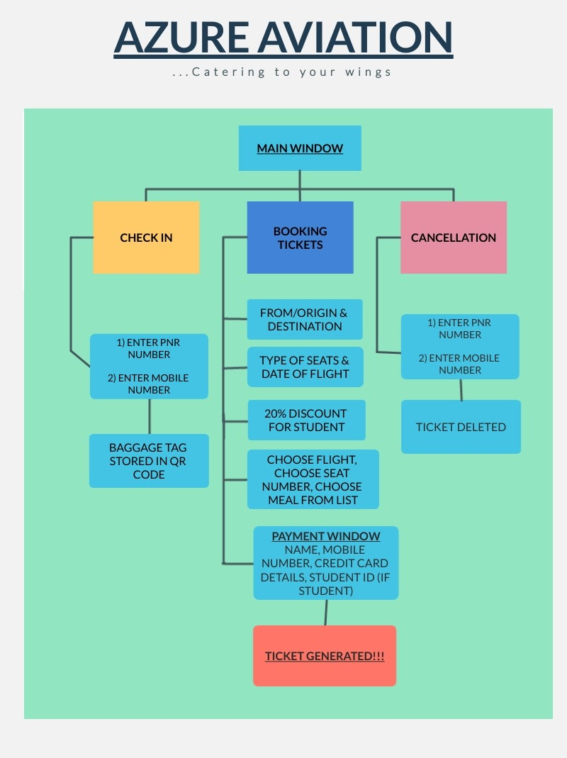**FLOWCHART**

**MODULES USED**

1. Tkinter
2. MySQL connector
3. Prettytable
4. Tkcalendar
5. Pyqrcode
6. Datetime
7. Colorama
8. Random

**TABLES USED**

Database = Airline

Table = Airline_reservation

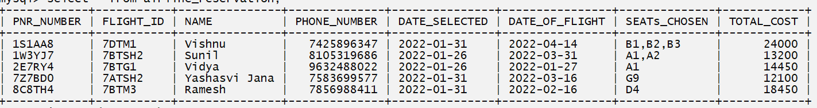

**SYSTEM REQUIREMENTS**

**PROCESSOR:**

11th Gen Intel(R) Core(TM) i5-1135G7 @ 2.40GHz 2.42 GHz

**OPERATING SYSTEM:**

Windows 11 Home Single Language

**INSTALLED RAM:**

8.00 GB

**SYSTEM TYPE:**

64-bit operating system, x64-based processor

**SOFTWARE REQUIREMENT:**

Python 3.95

MySQL Connector

**CODE**

# Importing required modules

from tkinter import *

from tkinter import messagebox,ttk

from tkcalendar import * # To have a graphic calendar object

from datetime import date # To use current date

from prettytable import PrettyTable # To print the overall ticket in nice format

import mysql.connector as myc

import random,colorama

from colorama import Fore # To add colors to terminal

from pyqrcode import create # To generate a qr code for baggage tag

colorama.init(autoreset=True)

# Initialising Main GUI root

root = Tk()

root.title("AZURE AVIATION!") # Adding a title to main root

root.iconbitmap('Logo.ico') # Adding an icon to root

root.geometry("1064x800") # Geometry of main Root window

canvas = Canvas(root,bg = "#ffffff",height = 800,width = 1064,bd = 0,highlightthickness = 0,relief = "ridge")

canvas.place(x = 0, y = 0)

# Initialising the mysql connection

database = myc.connect(user = 'root',password = 'tiger',host = 'localhost',database = 'airline')

mycursor = database.cursor()

SQL1 = 'CREATE TABLE IF NOT EXISTS AIRLINE_RESERVATION(PNR_NUMBER CHAR(6) PRIMARY KEY,FLIGHT_ID VARCHAR(6),NAME VARCHAR(50),PHONE_NUMBER BIGINT,DATE_SELECTED DATE,DATE_OF_FLIGHT DATE,SEATs_CHOSEN TEXT,TOTAL_COST DOUBLE)' # TEXT is used here because we need to separate seat numbers with comma and put in mysql database

mycursor.execute(SQL1)

# Returns the flightID, date of flight and seats chosen as a dictionary in which key is a tuple and value is a string

# If 2 passengers have same flight ID and same flight date then it takes their seats and puts them to values of dictionary

def CheckAllSeatsBooked():

D = {}

SQL = 'SELECT * FROM AIRLINE_RESERVATION'

mycursor.execute(SQL)

result = mycursor.fetchall()

for i in result:

if (i[1],i[5]) in D:

a = ','+i[6]

D[(i[1],i[5])]+=a # If 2 people have same flight id and date of flight then it appends their seats chosen to the dicitonary

else:

T = (i[1],i[5]) # If 2 people do not have same flight id or date of flight then simply put to dictionary

D[T] = i[6]

return D

def AllBooked():

flightIds = []

D = CheckAllSeatsBooked() # Returning the dictionary with flightids and their respective seats chosen

a = list(D.items())

for i in a:

if len(i[-1]) == 278: # if all seats are chosen then the length of such a list if 278

flightIds.append(i[0][0]) # Append all the flight ids of such flights with all seats booked to flightIds

return flightIds

# Validating if PNR is not entered and if PNR is entered proceed to PNRGeneration()

def CheckPNR():

SQL = 'SELECT * FROM AIRLINE_RESERVATION'

mycursor.execute(SQL)

result = mycursor.fetchall()

# If no records in mysql database

if len(result) == 0:

pass

else:

for i in result:

if i[0] == PNR: # If such a PNR already exists then make a new PNR

PNRGeneration()

else:

pass

# Formatting the list containing seats so as to add ',' after each seat number and put it as text in mysql database

def format(List_Pretty):

string = ','

return string.join(List_Pretty)# The output will look something like 'A1,A2,A3'

# Inserting the data into mysql table

def MYSQL_Insertion(List_SQL_Data):

SQL2 = 'INSERT INTO AIRLINE_RESERVATION(PNR_NUMBER,FLIGHT_ID,NAME,PHONE_NUMBER,DATE_SELECTED,DATE_OF_FLIGHT,SEATs_CHOSEN,TOTAL_COST) VALUES (%s,%s,%s,%s,%s,%s,%s,%s)'

mycursor.execute(SQL2,List_SQL_Data)

database.commit()

#=====GENERATING PNR NUMBER=====#

def PNRGeneration():

global PNR

L = [chr(i) for i in range(65,91)] # Generating Aphabets from A to Z

first,second,third = random.choice(L),random.choice(L),random.choice(L) # The 3 random alphabets to go in PNR number

PNR = str(random.randint(0,9)) + first + str(random.randint(0,9)) + second + third + str(random.randint(0,9)) # Generating random PNR number having 6 places of the form A1A2A3 randint from 0-9 means 0 and 9 both included

return PNR

def FlightSeat(Selected_FlightID):

L = []

SQL = 'SELECT * FROM AIRLINE_RESERVATION'

mycursor.execute(SQL)

result = mycursor.fetchall()

# Formating the time so as to come in MYSQL time format of year-month-day

def format(n):

return n.strftime("%Y-%m-%d")

# If nothing is in MYSQL database

if len(result) == 0:

return L

else:

for i in result:

if i[1] == Selected_FlightID and format(i[-3]) == g:

if len(i[-2]) == 1:

L.append(i[-2])

elif len(i[-2]) > 1:

Lst = [item.strip() for item in i[-2].split(',')]

L.extend(Lst)

elif len(i) == 0:

pass

return L

# Obtain the seat cost according to which flight selected and if student then give discount of 20%

def seatCost(seat_type_cost):

global Price

if is_Stud == 1:

if sel1.get() == 1:

Price = seat_type_cost[0] - seat_type_cost[0]*disc

elif sel2.get() == 1:

Price = seat_type_cost[1] - seat_type_cost[1]*disc

elif sel3.get() == 1:

Price = seat_type_cost[2] - seat_type_cost[2]*disc

else:

if sel1.get() == 1:

Price = seat_type_cost[0]

elif sel2.get() == 1:

Price = seat_type_cost[1]

elif sel3.get() == 1:

Price = seat_type_cost[2]

return Price

# Generating the Final ticket

def ticket():

global l1

global Selected_FlightID

# Obtaining the Flight ID according to what user chooses

if sel1.get() == 1:

Selected_FlightID = FlightID[0]

elif sel2.get() == 1:

Selected_FlightID = FlightID[1]

elif sel3.get() == 1:

Selected_FlightID = FlightID[2]

# Checking if user wants food

if wantFood == True:

food_type = Food_taken

cost_index = Food_List.index(food_type)

FoodCost = Food_Cost_List[cost_index]

quanCost = FoodCost*int(quan)

else:

quanCost = 0

# Checking which type of seat is chosen by user

if seat_Chosen == 'Economy':

sC = seatCost(cost_Economy)

elif seat_Chosen == 'First Class':

sC = seatCost(cost_1st_Class)

elif seat_Chosen == 'Business':

sC = seatCost(cost_Business)

# Calculating The Total Cost and generating Ticket

Total_Cost = seatno*sC + quanCost # Getting Total cost having seat and food quantity

Selected_Date = str(sel.get()) # Finding Date selected by user

Current_Date = str(today) # Getting current date

prettyprint_List = [PNRGeneration(),Selected_FlightID, name_entry.get(),Mobile_entry.get(),Current_Date,Selected_Date,format(l1),Total_Cost] # Data of ticket in List format

CheckPNR() # Checks if generated PNR already exists in mysql database if exists then generates new one

MYSQL_Insertion(prettyprint_List) # Inserts data into mysql database

table = PrettyTable(['PNR Number','Flight ID','Name','Phone Number','Date Selected ','Date of Flight','Seats Chosen','Total Cost'])

table.add_row(prettyprint_List) # Adding the row into pretty printed table

ticket_Payment = Toplevel() # Creating a new window

ticket_Payment.iconbitmap('Logo.ico')

ticket_Payment.title('ticket')

ticket_Lbl = Label(ticket_Payment,text = 'Your Ticket').grid(row=0,column=0)

nametable = Label(ticket_Payment , text = table , bg = 'white' , fg = 'black' , font = ('COURIER NEW' , 10)).grid(row=1,column=0)

Payment_root.destroy() # Destroying the main Payment window

# Checking if the Credit Card is valid by returning True and False

def checkCCcard():

cc_card = CreditCard_entry.get()

if cc_card.isdigit() == False or len(str(cc_card)) != 16 or int(cc_card)<=0:

return False

else:

return True

# Checking Validity of mobile number

def CheckMobile(MobileParameter):

Mobile = MobileParameter.get()

if Mobile.isdigit() == False or len(MobileParameter.get())!=10:

return False

else:

return True

# Checking if name entry is empty or if Credit Card is invalid or if Mobile is invalid

def FinalPay():

if name_entry.get() == '' or checkCCcard() == False or CheckMobile(Mobile_entry) == False :

messagebox.showerror('ERROR', 'Select Appropriate Data!',parent = frame1_Payment)

else:

ticket()

# Main Payment Window

def Payment():

global frame1_Payment

global name_entry

global bg_color_payment

global Mobile_entry

global CreditCard_entry

global Payment_root

Food_Display.destroy() # Destroying the Food window

# Configuring the Payment window

bg_color_payment = '#00BFFF'

Payment_root = Toplevel()

Payment_root.iconbitmap('Logo.ico')

Payment_root.geometry('800x600')

Payment_root.title('PAYMENT')

Payment_root.configure(bg = bg_color_payment) # Adding a color to Payment window

# Creating the payment Frame

frame1_Payment = Frame(Payment_root,bg = bg_color_payment)

frame2_Payment = Frame(Payment_root,bg = bg_color_payment)

# Creating and placing the objects in payment frame

Payment_Display = Label(frame2_Payment,text = 'Payment',font = ('Courier',30),bg=bg_color_payment).grid(row=0,column=0,padx=20)

payment_name = Label(frame1_Payment,text = 'Enter Name',bg = bg_color_payment).grid(row=0,column=0)

name_entry = Entry(frame1_Payment)

name_entry.grid(row=0,column=1,pady=5,padx=20)

payment_Mobile = Label(frame1_Payment, text = 'Enter Mobile Number',bg = bg_color_payment).grid(row = 1, column=0)

Mobile_entry = Entry(frame1_Payment)

Mobile_entry.grid(row=1, column=1,pady=5)

payment_CreditCard = Label(frame1_Payment, text = 'Enter Credit Card Number',bg = bg_color_payment).grid(row = 2, column=0,pady=5)

CreditCard_entry = Entry(frame1_Payment)

CreditCard_entry.grid(row=2, column=1,pady=5)

# Asking for student ID if user has ticked the Are you Student check box

if is_Stud == 1:

payment_StudID = Label(frame1_Payment, text = 'Enter Student ID',bg = bg_color_payment).grid(row = 3, column=0)

StudID_entry = Entry(frame1_Payment).grid(row=3, column=1,pady=5)

# Final Proceed to Payment Button

Payment_Btn = Button(frame1_Payment, text = 'Proceed to pay', command = FinalPay, font = ('Courier', 10)).grid(row = 4, column = 0, pady = 50, columnspan=2)

# Placing the Payment Frames

frame1_Payment.place(relx = 0.5,rely = 0.5,anchor=CENTER)

frame2_Payment.place(relx = 0.5,rely = 0.1,anchor=CENTER)

# Validating the quanity input given by user

def CheckQuan():

global quan

quan = quantity_input.get()

try:

# Making sure quantity is integer greater than 0

if int(quan)>0:

return False

else:

return True

except Exception: # If any other value given the return True

return True

# Validating for cases when food or quantity is invalid or empty fields

def FinalFood():

global Food_taken

if Food_Combo.get() == '' or CheckQuan():

messagebox.showerror('ERROR', 'Select Appropriate Data!',parent = frame1_Food)

else:

Food_taken = Food_Combo.get()

Payment()

# If Food button is unchecked

def no_Btn_click():

global wantFood

wantFood = False

Food_Display.destroy()

Payment()

# If Food button is checked

def yes_Btn_click():

global quantity_input

global frame1_Food

global Food_Combo

global wantFood

global Food_Cost_List

global Food_List

wantFood = True

yes_Btn = Button(frame1_Food,text = 'YES',command = yes_Btn_click, state = DISABLED, font = ('Courier', 10)).grid(row=0,column=1)

no_Btn = Button(frame1_Food, text = 'NO', command = no_Btn_click, state = DISABLED, font = ('Courier', 10)).grid(row=0, column=2)

# List of available foods

Food_List = ['Panner Sandwich (₹100)', 'Noodles (₹200)', 'Chicken Biryani (₹500)', 'Tacos (₹150)', 'Vada Pav (₹75)', 'Popcorn (₹100)', 'Cheese Pizza (₹250)','Pastry (₹80)','Mango Smoothi (₹50)', 'Mixed Fruit Juice (₹40)','Chocolate Mousse (₹90)']

# Respective Food Costs

Food_Cost_List = [100, 200, 500, 150 , 75, 100, 250, 80, 50, 40, 90]

# Adding objects to main Payment Window

Display_food_Lbl = Label(frame2_Food,text = 'Choose your Food',font = ('Courier',30),bg = bg_color_cancel).grid(row=0,column=0,padx=20)

Choose_Food = Label(frame1_Food,text = 'Choose your food',bg = bg_color_cancel).grid(row=1,column=0,pady=5,padx=20)

Food_Combo = ttk.Combobox(frame1_Food,values = Food_List)

Food_Combo.grid(row=1,column=1,padx=20)

quantity = Label(frame1_Food,text = 'Enter Quantity ',bg = bg_color_cancel).grid(row=2,column=0,padx=20)

quantity_input = Entry(frame1_Food,width=23)

quantity_input.grid(row=2,column=1,pady=5,padx=20)

PrcdToPay_Btn = Button(frame1_Food, text = 'Proceed to pay', command = FinalFood, font = ('Courier', 10)).grid(row = 3, column = 0, pady = 50, columnspan=2)

#Creating a window for users to select Food

def Food():

global Food_Display

global frame1_Food

global frame2_Food

global bg_color_cancel

# Configuring the main Food window

bg_color_cancel = '#00BFFF'

Food_Display = Toplevel()

Food_Display.iconbitmap('Logo.ico')

Food_Display.geometry('800x600')

Food_Display.title('CHOOSE FOOD')

Food_Display.configure(bg = bg_color_cancel)

# Creating the Frames to hold objects in Food window

frame1_Food = Frame(Food_Display,bg = bg_color_cancel)

frame2_Food = Frame(Food_Display,bg = bg_color_cancel)

# Adding objects to the main food window

want_food = Label(frame1_Food,text = 'Do you want food?',bg = bg_color_cancel).grid(row=0,column=0,pady=5)

yes_Btn = Button(frame1_Food,text = 'YES',command = yes_Btn_click, font = ('Courier', 10)).grid(row=0,column=1,pady=5)

no_Btn = Button(frame1_Food, text = 'NO', command = no_Btn_click, font = ('Courier', 10)).grid(row=0, column=2,pady=5)

# Placing the food frames

frame1_Food.place(relx = 0.5,rely = 0.5,anchor=CENTER)

frame2_Food.place(relx = 0.5,rely = 0.1,anchor=CENTER)

#=====MAIN FUNCTION TO GENERATE SEATING ARRANGEMENT=====#

def Seating():

Display_Level.destroy()

def Display_Seating():

global seats_Booked

if sel1.get() == 1:

Selected_FlightID = FlightID[0]

elif sel2.get() == 1:

Selected_FlightID = FlightID[1]

elif sel3.get() == 1:

Selected_FlightID = FlightID[2]

seats_Booked = FlightSeat(Selected_FlightID)

seat_List = [chr(i)+str(j) for i in range(65,74) for j in range(1,11)] # List containing all seat Numbers

# Displays seating and adds red NA to those seats already booked for a particular flight

def seat_selection():

for i in range(65,74):

for j in range(1,11):

if (chr(i)+str(j)) in seats_Booked:

print(Fore.RED+'NA',sep='',end=' ')

else:

print(chr(i),j,sep='',end=' ')

print()

seat_selection()

global seatno

print()

def again(seatno):

global l1

l1=[]

# After user selects number of seats

for i in range(1,seatno+1):

print('CHOOSING SEAT ',i)

choice=input("ENTER THE SEAT NUMBER: ")

# Validating if the seat entered by user is already booked by checking with mysql database

if choice in seats_Booked:

print(Fore.RED+'INVALID INPUT')

print(Fore.RED+"PLEASE ENTER ALL VALUES AGAIN")

print()

again(seatno) # Again goes to seat choosing function

else:

# If seat not in current List --> seat_List then append it to l1

# l1 is temporary list but seat_List is list of seats in that particular flight from mysql database

if choice in seat_List and choice not in l1:

l1.append(choice)

else:

print()

print(Fore.RED+'INVALID INPUT')

print(Fore.RED+"PLEASE ENTER ALL VALUES AGAINs")

again(seatno)

# Checking if the number of seats entered is valid and not a string or a decimal by using try and except

def ValidSeat():

global seatno

try:

print(Fore.YELLOW+'*'*35)

seatno=int(input('ENTER THE NUMBER OF SEATS YOU WANT:'))

# Validating seatno

if seatno<=0:

print(Fore.RED+'Enter Appropriate Data!')

print(Fore.YELLOW+'*'*30)

print()

Display_Seating()

else:

again(seatno) # Again to display choosing seat

for i in range(65,74):

for j in range(1,11):

if (chr(i)+str(j)) in l1 or (chr(i)+str(j)) in seats_Booked: # If the seat being chosen already exists in seats_Booked or in the temporary list l1

print(Fore.RED+'NA',end=' ')

else:

print(chr(i),j,sep='',end=' ')

print()

except Exception:

print(Fore.RED+"Invalid Seat number!")

print()

print(Fore.YELLOW+'*'*30)

print()

Display_Seating()

ValidSeat()

Display_Seating()

print()

print(Fore.YELLOW+"SELECT FOOD")

Food()

# Data Validation for Check Button

def OptError():

if sel1.get() == 1 and sel2.get() == 1 and sel3.get() == 1:

messagebox.showerror('ERROR', 'Select Appropriate Flight!',parent = frame1_Display_Flight)

elif sel1.get() == 1 and sel2.get() == 1 and sel3.get() == 0:

messagebox.showerror('ERROR', 'Select Appropriate Flight!',parent = frame1_Display_Flight)

elif sel1.get() == 1 and sel2.get() == 0 and sel3.get() == 1:

messagebox.showerror('ERROR', 'Select Appropriate Flight!',parent = frame1_Display_Flight)

elif sel1.get() == 0 and sel2.get() == 1 and sel3.get() == 1:

messagebox.showerror('ERROR', 'Select Appropriate Flight!',parent = frame1_Display_Flight)

elif sel1.get() == 0 and sel2.get() == 0 and sel3.get() == 0:

messagebox.showerror('ERROR', 'Select Appropriate Flight!',parent = frame1_Display_Flight)

if sel1.get() == 1 and sel2.get() == 0 and sel3.get() == 0:

Seating()

if sel1.get() == 0 and sel2.get() == 1 and sel3.get() == 0:

Seating()

if sel1.get() == 0 and sel2.get() == 0 and sel3.get() == 1:

Seating()

# Generating Flights-IDs, Flight-Time

def From_To_Places(From_Entry,To_Entry,flight_IDs):

global sel1,sel2,sel3

global opt_box_1,opt_box_2,opt_box_3

global is_Stud

global FlightID

global cost_Business,cost_1st_Class,cost_Economy

global disc

FlightID = flight_IDs

def Display(cost):

flight_1 = Label(frame1_Display_Flight,text = "Flight 1 (Connect)",font = ("Arial",12), bg = bg_color).grid(row=0,column=0,padx=30,pady=5)

flight_2 = Label(frame1_Display_Flight,text = "Flight 2 (Non Stop)",font = ("Arial",12), bg = bg_color).grid(row=1,column=0,padx=30,pady=5)

flight_3 = Label(frame1_Display_Flight,text = "Flight 3 (Non Stop)",font = ("Arial",12), bg = bg_color).grid(row=2,column=0,padx=30,pady=5)

flight_id_1 = Label(frame1_Display_Flight,text = flight_IDs[0],font = ("Arial",12), bg = bg_color).grid(row=0,column=1,padx=30,pady=5)

flight_id_2 = Label(frame1_Display_Flight,text = flight_IDs[1],font = ("Arial",12), bg = bg_color).grid(row=1,column=1,padx=30,pady=5)

flight_id_3 = Label(frame1_Display_Flight,text = flight_IDs[2],font = ("Arial",12), bg = bg_color).grid(row=2,column=1,padx=30,pady=5)

flight_time_1 = Label(frame1_Display_Flight,text = Flight_Times[0],font = ("Arial",12), bg = bg_color).grid(row=0,column=2,padx=30)

flight_time_2 = Label(frame1_Display_Flight,text = Flight_Times[1],font = ("Arial",12),bg = bg_color).grid(row=1,column=2,padx=30)

flight_time_3 = Label(frame1_Display_Flight,text = Flight_Times[2],font = ("Arial",12),bg = bg_color).grid(row=2,column=2,padx=30)

# If Not a student then no 20% discount

if is_Stud == 0:

cost_1 = Label(frame1_Display_Flight,text = '₹'+str(cost[0]),font = ("Arial",12),bg = bg_color).grid(row=0,column=3,padx=30)

cost_2 = Label(frame1_Display_Flight,text = '₹'+str(cost[2]),font = ("Arial",12),bg = bg_color).grid(row=1,column=3,padx=30)

cost_3 = Label(frame1_Display_Flight,text = '₹'+str(cost[1]),font = ("Arial",12),bg = bg_color).grid(row=2,column=3,padx=30)

# If student then giving 20% discount

elif is_Stud == 1:

cost_1 = Label(frame1_Display_Flight,text = '₹'+str(cost[0]-cost[0]*disc),font = ("Arial",12),bg = bg_color).grid(row=0,column=3,padx=30)

cost_2 = Label(frame1_Display_Flight,text = '₹'+str(cost[2]-cost[2]*disc),font = ("Arial",12),bg = bg_color).grid(row=1,column=3,padx=30)

cost_3 = Label(frame1_Display_Flight,text = '₹'+str(cost[1]-cost[1]*disc),font = ("Arial",12),bg = bg_color).grid(row=2,column=3,padx=30)

opt_box_1 = Checkbutton(frame1_Display_Flight,variable=sel1,onvalue=1,offvalue=0,bg = bg_color).grid(row=0,column=4)

opt_box_2 = Checkbutton(frame1_Display_Flight,variable=sel2,onvalue=1,offvalue=0,bg = bg_color).grid(row=1,column=4)

opt_box_3 = Checkbutton(frame1_Display_Flight,variable=sel3,onvalue=1,offvalue=0,bg = bg_color).grid(row=2,column=4)

D = AllBooked() # Getting the list with only flight ids where all seats are booked

if len(D) == 0: # If such length is 0 then dont do anything

pass

else:

for i in D:

if i not in FlightID: # If the flight id in allBooked is not in the selectedFlight id

pass

else:

index = FlightID.index(i) # Getting index of the flight id from its list

if index == 0:

opt_box_1 = Checkbutton(frame1_Display_Flight,variable=sel1,onvalue=1,offvalue=0,bg = bg_color,state = DISABLED).grid(row=0,column=4)

booked_lbl = Label(frame1_Display_Flight,text = "(All seats Booked!)",foreground='red').grid(row=0,column=5)

if index == 1:

opt_box_2 = Checkbutton(frame1_Display_Flight,variable=sel2,onvalue=1,offvalue=0,bg = bg_color,state = DISABLED).grid(row=1,column=4)

booked_lbl = Label(frame1_Display_Flight,text = "(All seats Booked!)",foreground='red').grid(row=1,column=5)

if index == 2:

opt_box_3 = Checkbutton(frame1_Display_Flight,variable=sel3,onvalue=1,offvalue=0,bg = bg_color,state = DISABLED).grid(row=2,column=4)

booked_lbl = Label(frame1_Display_Flight,text="(All seats Booked!)",foreground='red').grid(row=2,column=5)

else:

pass

display_Btn = Button(frame1_Display_Flight,text = 'CONFIRM',command = OptError, font = ('Courier', 10)).grid(row=4,column=1,padx=20,ipadx=30,pady=(40,0),columnspan=2)

From = From_Entry

To = To_Entry

is_Stud = var1.get()

sel1 = IntVar() # 0 if button not clicked, 1 if button clicked

sel2 = IntVar() # 0 if button not clicked, 1 if button clicked

sel3 = IntVar() # 0 if button not clicked, 1 if button clicked

disc = 0.2 # Discount offered by Azure Aviation for students

Flight_Times = ['6:00 AM','2:00 PM','8:00 PM'] # Flight times

# Seat costs for different types

cost_Economy = [6000.0,8000.0,10000.0]

cost_Business = [10000.0,12000.0,14000.0]

cost_1st_Class = [14000.0,16000.0,18000.0]

if seat_Chosen == 'Economy':

Display(cost_Economy)

elif seat_Chosen == 'First Class':

Display(cost_1st_Class)

elif seat_Chosen == 'Business':

Display(cost_Business)

# Main Search Flight window

def Search_Flight():

global frame1_Display_Flight

global frame2_Display_Flight

global Flight_Ids

global bg_color

global Display_Level

global Flight_ID_NestedList

global booked

# Configuring the Search Flight window

Top.destroy()

Display_Level = Toplevel()

Display_Level.iconbitmap('Logo.ico')

bg_color = '#00BFFF'

frame1_Display_Flight = Frame(Display_Level,bg = bg_color)

frame2_Display_Flight = Frame(Display_Level,bg = bg_color)

# Creating the search flight window

Display_Level.geometry('850x600')

Display_Level.title('Display Flights')

Display_Level.configure(bg = bg_color)

# Creating main objects on search flight window

Display_flight_Lbl = Label(frame2_Display_Flight,text = 'Displaying Flights...',font = ('Courier',30),bg = bg_color).grid(row=0,column=0)

SubHeading_Lbl = Label(frame2_Display_Flight,text = '(Flights, Flight ID, Departure Time, Price)',font = ('Arial',15), bg = bg_color).grid(row=1,column=0,pady=(0,40))

#=====FLIGHT IDs=====#

Flight_ID_NestedList = [['7BTD1','7BTD2','7BTD3'],['7BTM1','7BTM2','7BTM3'],['7BTA1','7BTA2','7BTA3'],['7BTSH1','7BTSH2','7BTSH3'],['7BTG1','7BTG2','7BTG3'],['7DTB1','7DTB2','7DTB3'],['7DTM1','7DTM2','7DTM3'],['7DTA1','7DTA2','7DTA3'],['7DTSH1','7DTSH2','7DTSH3'],['7DTG1','7DTG2','7DTG3'],['7MTB1','7MTB2','7MTB3'],['7MTD1','7MTD2','7MTD3'],['7MTA1','7MTA2','7MTA3'],['7MTSH1','7MTSH2','7MTSH3'],['7MTG1','7MTG2','7MTG3'],['7ATSH1','7ATSH2','7ATSH3'],['7ATD1','7ATD2','7ATD3'],['7ATB1','7ATB2','7ATB3'],['7ATM1','7ATM2','7ATM3'],['7ATG1','7ATG2','7ATG3'],['7SHTD1','7SHTD2','7SHTD3'],['7SHTB1','7SHTB2','7SHTB3'],['7SHTA1','7SHTA2','7SHTA3'],['7SHTM1','7SHTM2','7SHTM3'],['7SHTG1','7SHTG2','7SHTG3'],['7GTB1','7GTB2','7GTB3'],['7GTD1','7GTD2','7GTD3'],['7GTM1','7GTM2','7GTM3'],['7GTA1','7GTA2','7GTA3'],['7GTSH1','7GTSH2','7GTSH3']]

# Cases to check From and To Location from users choice and pass to function From_To_Places along with its Flight ID

if From_Entry == 'Bengaluru' and To_Entry == 'Delhi':

From_To_Places(From_Entry,To_Entry,Flight_ID_NestedList[0])

elif From_Entry == 'Bengaluru' and To_Entry == 'Mumbai':

From_To_Places(From_Entry,To_Entry,Flight_ID_NestedList[1])

elif From_Entry == 'Bengaluru' and To_Entry == 'Ahmedabad':

From_To_Places(From_Entry,To_Entry,Flight_ID_NestedList[2])

elif From_Entry == 'Bengaluru' and To_Entry == 'Shillong':

From_To_Places(From_Entry,To_Entry,Flight_ID_NestedList[3])

elif From_Entry == 'Bengaluru' and To_Entry == 'Goa':

From_To_Places(From_Entry,To_Entry,Flight_ID_NestedList[4])

elif From_Entry == 'Delhi' and To_Entry == 'Bengaluru':

From_To_Places(From_Entry,To_Entry,Flight_ID_NestedList[5])

elif From_Entry == 'Delhi' and To_Entry == 'Mumbai':

From_To_Places(From_Entry,To_Entry,Flight_ID_NestedList[6])

elif From_Entry == 'Delhi' and To_Entry == 'Ahmedabad':

From_To_Places(From_Entry,To_Entry,Flight_ID_NestedList[7])

elif From_Entry == 'Delhi' and To_Entry == 'Shillong':

From_To_Places(From_Entry,To_Entry,Flight_ID_NestedList[8])

elif From_Entry == 'Delhi' and To_Entry == 'Goa':

From_To_Places(From_Entry,To_Entry,Flight_ID_NestedList[9])

elif From_Entry == 'Mumbai' and To_Entry == 'Bengaluru':

From_To_Places(From_Entry,To_Entry,Flight_ID_NestedList[10])

elif From_Entry == 'Mumbai' and To_Entry == 'Delhi':

From_To_Places(From_Entry,To_Entry,Flight_ID_NestedList[11])

elif From_Entry == 'Mumbai' and To_Entry == 'Ahmedabad':

From_To_Places(From_Entry,To_Entry,Flight_ID_NestedList[12])

elif From_Entry == 'Mumbai' and To_Entry == 'Shillong':

From_To_Places(From_Entry,To_Entry,Flight_ID_NestedList[13])

elif From_Entry == 'Mumbai' and To_Entry == 'Goa':

From_To_Places(From_Entry,To_Entry,Flight_ID_NestedList[14])

elif From_Entry == 'Ahmedabad' and To_Entry == 'Shillong':

From_To_Places(From_Entry,To_Entry,Flight_ID_NestedList[15])

elif From_Entry == 'Ahmedabad' and To_Entry == 'Delhi':

From_To_Places(From_Entry,To_Entry,Flight_ID_NestedList[16])

elif From_Entry == 'Ahmedabad' and To_Entry == 'Bengaluru':

From_To_Places(From_Entry,To_Entry,Flight_ID_NestedList[17])

elif From_Entry == 'Ahmedabad' and To_Entry == 'Mumbai':

From_To_Places(From_Entry,To_Entry,Flight_ID_NestedList[18])

elif From_Entry == 'Ahmedabad' and To_Entry == 'Goa':

From_To_Places(From_Entry,To_Entry,Flight_ID_NestedList[19])

elif From_Entry == 'Shillong' and To_Entry == 'Delhi':

From_To_Places(From_Entry,To_Entry,Flight_ID_NestedList[20])

elif From_Entry == 'Shillong' and To_Entry == 'Bengaluru':

From_To_Places(From_Entry,To_Entry,Flight_ID_NestedList[21])

elif From_Entry == 'Shillong' and To_Entry == 'Ahmedabad':

From_To_Places(From_Entry,To_Entry,Flight_ID_NestedList[22])

elif From_Entry == 'Shillong' and To_Entry == 'Mumbai':

From_To_Places(From_Entry,To_Entry,Flight_ID_NestedList[23])

elif From_Entry == 'Shillong' and To_Entry == 'Goa':

From_To_Places(From_Entry,To_Entry,Flight_ID_NestedList[24])

elif From_Entry == 'Goa' and To_Entry == 'Bengaluru':

From_To_Places(From_Entry,To_Entry,Flight_ID_NestedList[25])

elif From_Entry == 'Goa' and To_Entry == 'Delhi':

From_To_Places(From_Entry,To_Entry,Flight_ID_NestedList[26])

elif From_Entry == 'Goa' and To_Entry == 'Mumbai':

From_To_Places(From_Entry,To_Entry,Flight_ID_NestedList[27])

elif From_Entry == 'Goa' and To_Entry == 'Ahmedabad':

From_To_Places(From_Entry,To_Entry,Flight_ID_NestedList[28])

elif From_Entry == 'Goa' and To_Entry == 'Shillong':

From_To_Places(From_Entry,To_Entry,Flight_ID_NestedList[29])

booked = Flight_ID_NestedList[29]

# Placing the Display Flight Frames

frame1_Display_Flight.place(relx = 0.5,rely = 0.5,anchor=CENTER)

frame2_Display_Flight.place(relx = 0.5,rely = 0.1,anchor=CENTER)

# Check Button for availing for Student discount

def Check_Btn():

global var1

var1 = IntVar()

student_chk = Checkbutton(frame1, text ="Are You a student?", variable = var1,onvalue=1,offvalue=0, bg = bgcolor,font=('Arial', 12))

student_chk.deselect()

student_chk.grid(row=4,column=0,ipadx=50,pady=(30,0),columnspan=3)

Submit_Btn = Button(frame1,text = 'Search Flight', command=Search_Flight, font = ('Courier', 10)).grid(row=5,column=0,ipadx=50,pady=30,columnspan=3)

# Building A Date Picker calendar

def calendar():

global sel

def submit():

global string

global g

g = sel.get() # Getting Date entered by User

string = str(g)

crnt_date = str(today) # Getting current Date

year = int(string[2:4])

if g<=str(crnt_date) or year!=22: # Validating the Date

messagebox.showerror("ERROR",'Choose Correct Date',parent = frame1)

else:

Check_Btn()

sel = StringVar() # Holder to hold the date selected

Date_Lbl = Label(frame1,text = 'Departure Date',font = ("Arial",15),bg = bgcolor).grid(row=3,column=0)

Date_Entry = DateEntry(frame1, selectmode = 'day', year = 2022, month = 2, day=1,date_pattern='yyyy-mm-dd', textvariable = sel,width=20) # Tkinter calendar to select the date of flight

Date_Entry.grid(row = 3, column=1)

global today

today = date.today() # Obtaining todays date

cal_Submit = Button(frame1,text = 'SUBMIT',command=submit, font = ('Courier', 10)).grid(row=3,column=2, pady = 5)

# Checking is no seats chosen else run calendar function

def seatSubmit():

global seat_Chosen

seat_Chosen = seat_type.get()

if seat_Chosen == '':

messagebox.showerror("ERROR",'Choose Appropriate Data',parent = frame1)

else:

calendar()

# Function to be called after user selects destination Flight

def To():

global seat_type

global To_Entry

seat = StringVar()

To_Entry = To_Places.get()

if To_Entry == '': # Checking if To Entry combobox is emppty

messagebox.showerror("ERROR", "Please Fill the Field!",parent = frame1)

else:

seat_types = ['First Class','Business','Economy']

pass_lbl = Label(frame1, text = "Seat Type",bg = bgcolor,font = ("Arial",15)).grid(row=2,column=0)

seat_type = ttk.Combobox(frame1,values = seat_types)

seat_type.grid(row=2,column=1)

pass_entry_submit = Button(frame1,text = 'SUBMIT',command=seatSubmit, font = ('Courier', 10)).grid(row=2,column=2,padx=20,pady=5)

# Function to the button SUBMIT next to From places

def From():

global To_Places

global From_Entry

L = ['Bengaluru', 'Delhi','Mumbai','Ahmedabad', 'Shillong', 'Goa']

From_Entry = From_places.get() # Fetching input from From_places box

# Checking for validity

if From_Entry == '':

messagebox.showerror("ERROR", "Please Fill the Field!",parent = frame1)

else:

L.remove(From_Entry) # If the From place exists in To places remove it

To_Lbl = Label(frame1,text = "To",bg=bgcolor,font = ("Arial",15)).grid(row=1,column=0)

To_Places = ttk.Combobox(frame1,values = L)

To_Places.grid(row = 1, column=1)

to_places_submit = Button(frame1,text = 'SUBMIT',command = To, font = ('Courier', 10)).grid(row=1,column=2,padx=20,pady=5)

#=====BOOKING WINDOW=====#

def Booking():

global bgcolor

global frame1

global From_places

global Top

L = ['Bengaluru', 'Delhi','Mumbai','Ahmedabad', 'Shillong', 'Goa']

bgcolor = '#00BFFF'

Top = Toplevel()

Top.iconbitmap('Logo.ico')

Top.geometry('800x600')

Top.title('Booking Ticket')

Top.configure(bg = bgcolor)

# Creating Booking Frames

frame1 = Frame(Top,bg = bgcolor)

frame2 = Frame(Top,bg = bgcolor)

# Creating and placing the Objects on the booking Frame

Booking_Lbl = Label(frame2,text = 'BOOKING TICKET',bg = bgcolor ,font = ('Courier',30) ).grid(row=0,column=0)

From_lbl = Label(frame1, text = "From",bg =bgcolor,font = ("Arial",15)).grid(row=0,column=0)

From_places = ttk.Combobox(frame1,values=L)

From_places.grid(row=0,column=1)

from_places_submit = Button(frame1,text = 'SUBMIT',command=From, font = ('Courier', 10)).grid(row=0,column=2,padx=20,pady=5)

space_label = Label(frame1,text = ' '*50,bg = bgcolor).grid(row=3,column=0)

# Placing the Frames

frame2.place(relx = 0.5,rely = 0.1,anchor=CENTER)

frame1.place(relx=0.5,rely=0.5,anchor=CENTER)

#=====CANCELLATION - DATA VALIDATION=====#

def CancelTicket():

string_PNR = str(PNR_entry_no)

# Displaying the details when ticket is deleted

SQL = "DELETE FROM AIRLINE_RESERVATION WHERE PNR_NUMBER = %s"

statement = f'''

Ticket Deleted!

PNR Number : {record[0][0]}

Passenger Name : {record[0][2]}

Flight Number : {record[0][1]}

Mobile Number : {record[0][3]}

'''

mycursor.execute(SQL,(string_PNR,))

database.commit()

messagebox.showinfo("DELETED!",statement,parent = frame1_cancellation)

# Checking if the Phone number entered really exists for that particular PNR no by comparing with mysql database

def Checker(result,PNR_entry_no):

global record

temp = 0

record = []

for i in result:

if PNR_entry_no == i[0] and int(Phone.get())==i[3]:

record.append(i) # Appending record with details where PNR_entry_no and Phone.get() matches with record in mysql

temp = 1 # Temporary variable to hold 1

if temp == 0:

messagebox.showerror("ERROR", "Ticket Does not Exist!",parent = frame1_cancellation) # Parent makes the window pops on the same frame

# If temp !=0

else:

CancelTicket()

# Checking if the ticket entered really exists by comparing with mysql database

def TicketExists():

global PNR_entry_no

PNR_entry_no = PNRno.get()

SQL = 'SELECT * FROM AIRLINE_RESERVATION'

mycursor.execute(SQL)

result = mycursor.fetchall()

# If no records in mysql table

if len(result) == 0:

messagebox.showerror("ERROR", "Ticket does not exist!",parent = frame1_cancellation)

else:

Checker(result,PNR_entry_no)

# Cancellation of Record

def CancelDetails():

# If phone number if invalid

if CheckMobile(Phone) == False:

messagebox.showerror("ERROR", "INVALID ENTRIES!",parent = frame1_cancellation)

else:

TicketExists()

#=================CANCELLATION WINDOW==============#

def Cancellation():

global Phone

global frame1_cancellation

global PNRno

bg_color_cancel = '#00BFFF'

Display = Toplevel()

Display.iconbitmap('Logo.ico')

Display.geometry('800x600')

Display.title('CANCELLATION')

Display.configure(bg = bg_color_cancel)

# Creating Frames for cancellation

frame1_cancellation = Frame(Display,bg = bg_color_cancel)

frame2_cancellation = Frame(Display,bg = bg_color_cancel)

# Creating and placing the window objects

Cancel_Lbl = Label(frame2_cancellation,text = 'Cancellation',bg = bg_color_cancel ,font = ('Courier',30)).grid(row=0,column=0)

PNR_lbl = Label(frame1_cancellation, text = 'Enter PNR Number', bg = bg_color_cancel, font = ('Arial',12)).grid(row = 0,column=0,pady=5, padx =20)

PNRno = Entry(frame1_cancellation, width = 20)

PNRno.grid(row=0,column=1)

Phone_lbl = Label(frame1_cancellation, text = 'Enter Phone No', bg = bg_color_cancel,font = ('Arial',12)).grid(row = 2,column=0,pady=5)

Phone = Entry(frame1_cancellation, width = 20)

Phone.grid(row=2,column=1)

Final_Btn = Button(frame1_cancellation,text = 'Confirm',command = CancelDetails, font = ('Courier', 10)).grid(row=3,column=0,pady = 20, ipadx = 20, columnspan=2)

# Placing the frames

frame1_cancellation.place(relx = 0.5,rely = 0.5,anchor=CENTER)

frame2_cancellation.place(relx = 0.5,rely = 0.1,anchor=CENTER)

#===================BAGGAGE TAG====================#

def baggage_in_QR():

# Final printing when QR code is scanned

s = f'''

\t\t\t\tBAGGAGE TAG

\t\t\t\tAzure Aviation Happy Flying!

\t\t\t\t25Kg Luggage Permitted

***********************************

PNR Number : {Check_in_record[0][0]}

Passenger Name : {Check_in_record[0][2]}

Flight Number : {Check_in_record[0][1]}

Seat(s) Chosen: {Check_in_record[0][6]}

Date of Flight: {Check_in_record[0][5]}

Mobile Number : {Check_in_record[0][3]}

'''

return s # Returning the formatted string

#=====BAGGAGE TAG WINDOW=====#

def Show_baggage_tag(PNR_entry_no):

global frame1_Check_in

bg_color_baggage_tag = '#00BFFF'

Display = Toplevel()

Display.iconbitmap('Logo.ico')

Display.geometry('800x600')

Display.title('Baggage Tag')

Display.configure(bg = bg_color_baggage_tag)

# Creating the window Frames

frame1_baggage_tag = Frame(Display,bg = bg_color_baggage_tag)

frame2_baggage_tag = Frame(Display,bg = bg_color_baggage_tag)

# Baggage tag window objects

Baggage_tag_heading = Label(frame2_baggage_tag, text = 'Baggage Tag', bg = bg_color_baggage_tag, font = ('Courier',30)).grid(row = 0, column=0)

Baggage_tag_SubHeading = Label(frame2_baggage_tag, text = 'Your Baggage Tag Has Been Successfully Generated ✅ \n Scan to Print Baggage Tag!', bg = bg_color_baggage_tag,font = ('Courier',15)).grid(row = 1, column=0)

image_view = Label(frame1_baggage_tag)

image_view.grid(row=0,column=1)

#=====QR CODE=====#

QR_Data = baggage_in_QR()

img = create(QR_Data) # Creating the QR code from QR_Data

test = img.xbm(scale = 2) # Scaling the image to 2

global xbm_image

xbm_image = BitmapImage(data=test,foreground='Blue',background='yellow')# Creating a BitmapImage out of the QR code

image_view.config(image = xbm_image) # Configuring the Label with the QR code

# Packing the Frames

frame1_baggage_tag.place(relx = 0.5,rely = 0.5,anchor=CENTER)

frame2_baggage_tag.place(relx = 0.5,rely = 0.1,anchor=CENTER)

# Checking validity of PNR and Phone entered with mysql database

def Checker_baggage_tag(result,PNR_entry_no):

global Check_in_record

Check_in_record = []

temp = 0

for i in result:

if PNR_entry_no == i[0] and int(Phone.get())==i[3]: # If PNR_entry_no == i[0] and phone.get() then append to Check_in_record

Check_in_record.append(i)

temp = 1

if temp == 0:

messagebox.showerror("ERROR", "Ticket Does not Exist!",parent = frame1_Check_in)

else:

Show_baggage_tag(PNR_entry_no)

# Checking validity of PNR number by connecting to mysql

def Ticket_baggage():

global result

global PNR_entry_no

PNR_entry_no = PNRno.get()

SQL = 'SELECT * FROM AIRLINE_RESERVATION'

mycursor.execute(SQL)

result = mycursor.fetchall()

# If no records in MYSQL database

if len(result) == 0:

messagebox.showerror("ERROR","INVALID ENTRIES!",parent = frame1_Check_in)

else:

Checker_baggage_tag(result,PNR_entry_no)

# Checking if Entries are valid

def Baggage_tag():

global PNR_entry_no

PNR_entry_no = PNRno.get()

# Checking if PNR entry is empty or is Phone entry is invalid or if Phone entered is not valid

if PNRno.get() == '' or Phone.get() == '':

messagebox.showerror("ERROR", "Please Fill the Field",parent = frame1_Check_in)

elif Phone.get().isalpha():

messagebox.showerror("ERROR", "Please Fill appropriately",parent = frame1_Check_in)

else:

Ticket_baggage()

#=====CHECK IN WINDOW=====#

def Check_in():

global frame1_Check_in

global PNRno

global Phone

# Configuring the Check in Window

bg_color_check_in = '#00BFFF'

Display = Toplevel()

Display.iconbitmap('Logo.ico')

Display.geometry('800x600')

Display.title('Check in')

Display.configure(bg = bg_color_check_in)

# Creating Check in Frames

frame1_Check_in = Frame(Display,bg = bg_color_check_in)

frame2_Check_in = Frame(Display,bg = bg_color_check_in)

# Creating and placing objects in Check in window

Checkin_Lbl = Label(frame2_Check_in,text = 'CHECKING IN',bg = bg_color_check_in ,font = ('Courier',30)).grid(row=0,column=0)

PNR_lbl = Label(frame1_Check_in, text = 'Enter PNR number', bg = bg_color_check_in,font = ('Arial',12)).grid(row = 0,column=0,pady=5, padx = 20)

PNRno = Entry(frame1_Check_in, width = 20)

PNRno.grid(row=0,column=1)

Phone_lbl = Label(frame1_Check_in, text = 'Enter Phone no', bg = bg_color_check_in,font = ('Arial',12)).grid(row = 2,column=0,pady=10)

Phone = Entry(frame1_Check_in, width = 20)

Phone.grid(row=2,column=1)

Final_Btn = Button(frame1_Check_in,text = 'Confirm', font = ('Courier', 10),padx=3, pady = 1, command = Baggage_tag).grid(row=3,column=0,pady = 15, ipadx = 15, columnspan=2)

# Placing the Check in Frames

frame1_Check_in.place(relx = 0.5,rely = 0.5,anchor=CENTER)

frame2_Check_in.place(relx = 0.5,rely = 0.1,anchor=CENTER)

#=============MAIN WINDOW OBJECTS=============#

check_in_pic = PhotoImage(file = f"Check_in.png")

Checkin_button = Button(image = check_in_pic,borderwidth = 0,highlightthickness = 0,relief = "flat",command=Check_in)

Checkin_button.place(x = 671, y = 556,width = 294,height = 65)

img1 = PhotoImage(file = f"cancel.png")

Cancellation_button = Button(image = img1,borderwidth = 0,highlightthickness = 0,relief = "flat",command=Cancellation)

Cancellation_button.place(x = 671, y = 442,width = 294,height = 69)

img2 = PhotoImage(file = f"booking.png")

Booking_button = Button(image = img2,borderwidth = 0,highlightthickness = 0,relief = "flat",command=Booking)

Booking_button.place(x = 671, y = 334,width = 293,height = 65)

background_img = PhotoImage(file = f"background.png")

background = canvas.create_image(529.0, 400.0,image=background_img)

# Making the Main window non-resizable

root.resizable(False, False)

# Running the mainloop application

root.mainloop()

'''

To View QR code on PC

QR SCANNER: https://www.imgonline.com.ua/eng/scan-qr-bar-code.php

'''

**PROJECT SCREENSHOTS**

**MAIN WINDOW:**

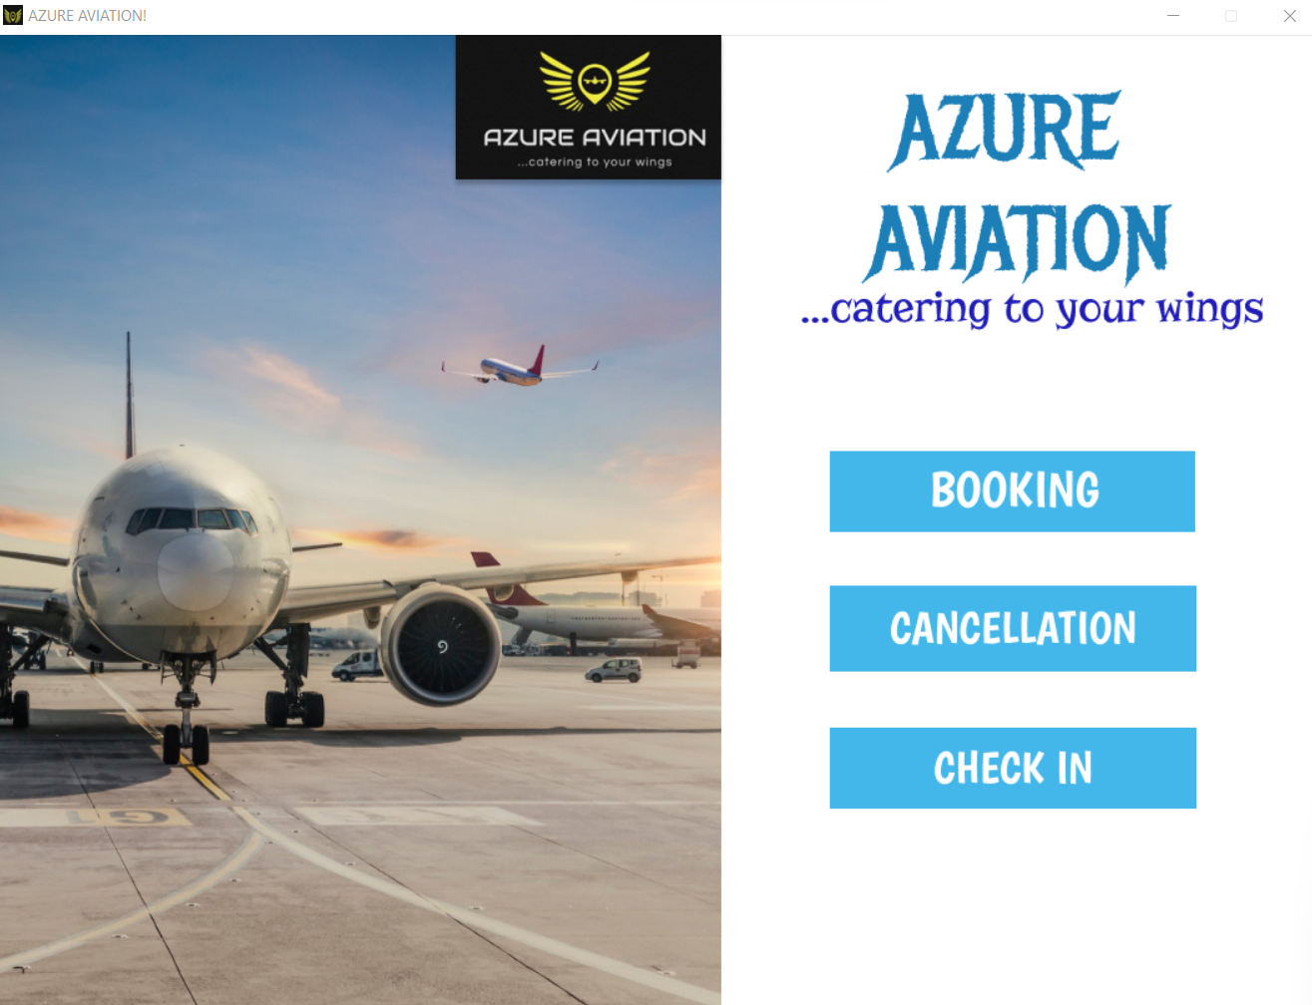

**BOOKING TICKETS:**

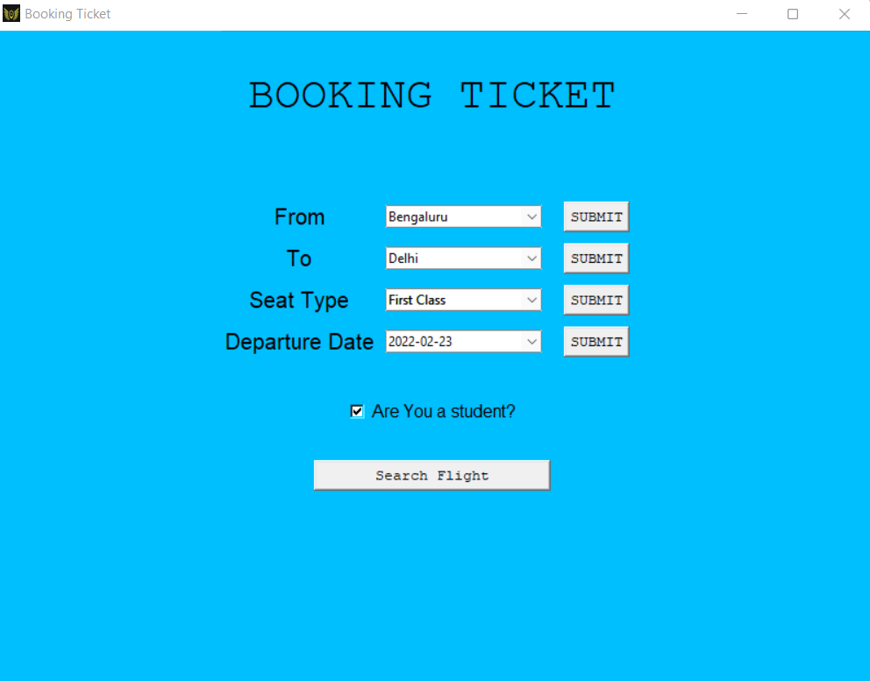

**DISPLAYING TICKETS:**

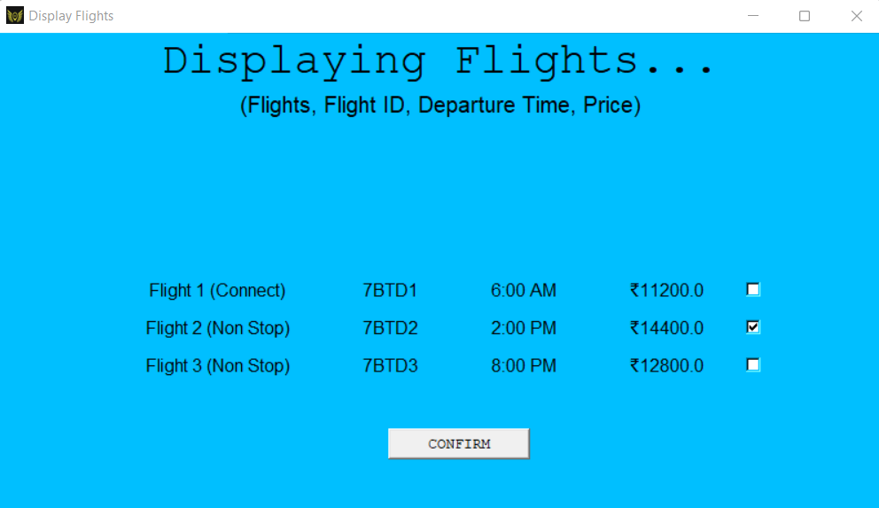

**SEATING:**

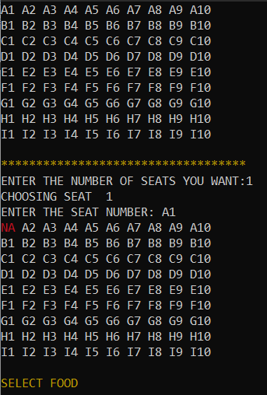

**CHOOSING FOOD:**

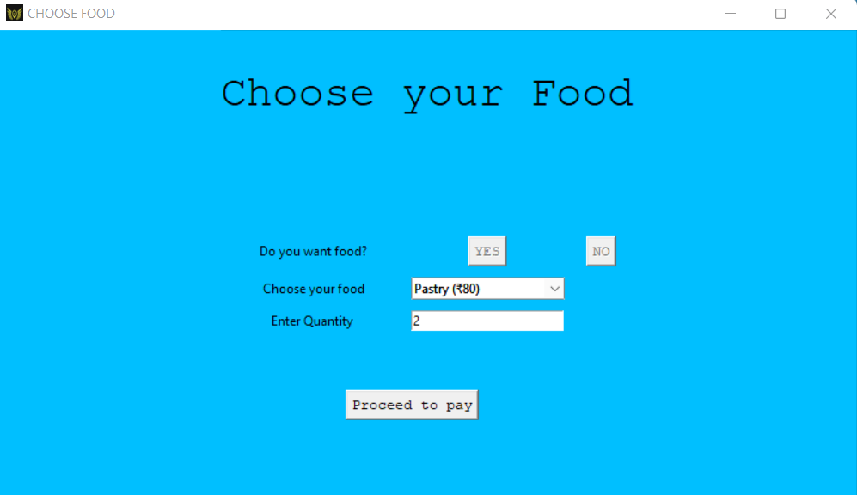

**PAYMENT WINDOW:**

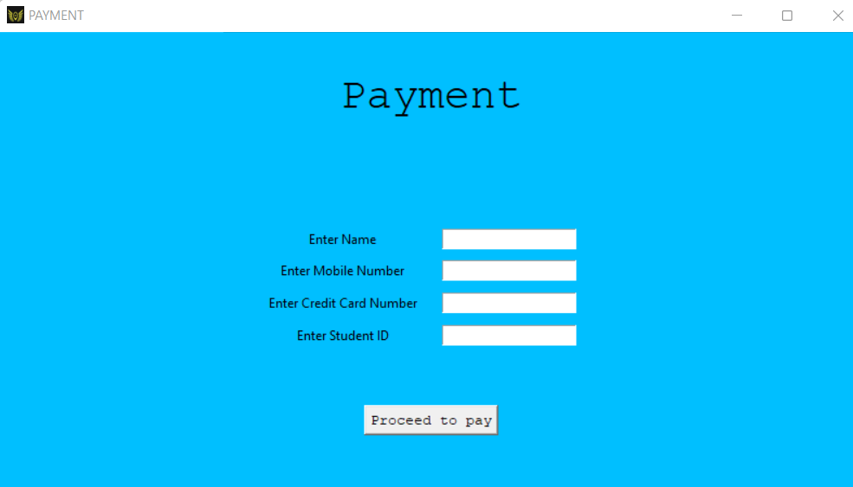

(DETAILS TO BE FILLED IN THE RESPECTIVE REGION )

**TICKET DISPLAY:**

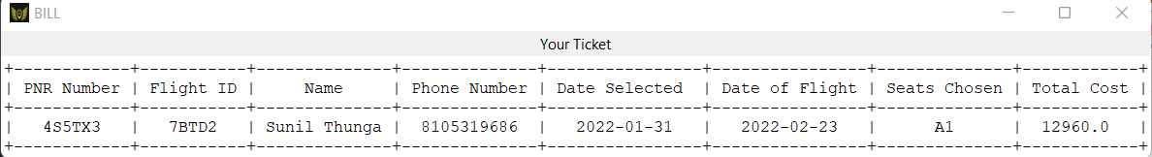

**CHECKING IN TO FLIGHT:**

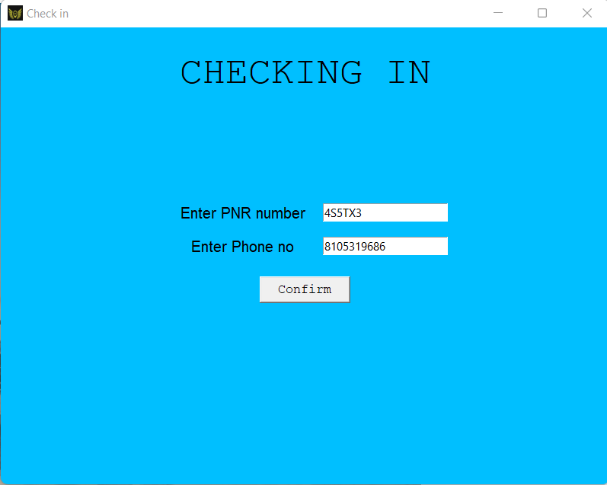

**DISPLAYING BAGGAGE TAG:**

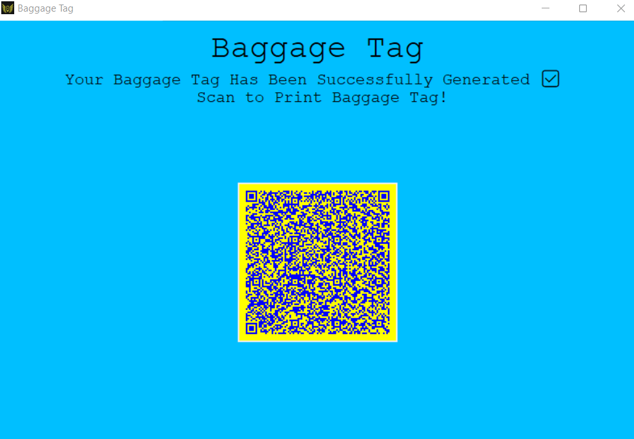

**DISPLAYING QR CODE SCAN:**

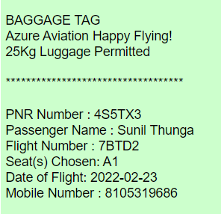

**CANCELLING TICKETS:**

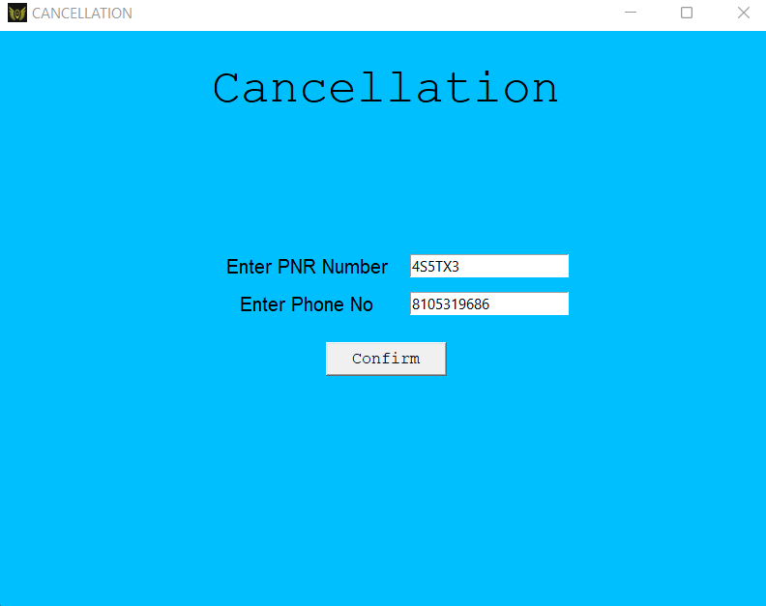

**DELETION OF TICKET:**

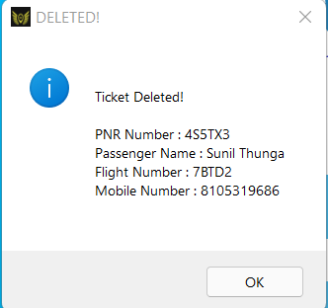

**FULL FLIGHT BOOKED:**

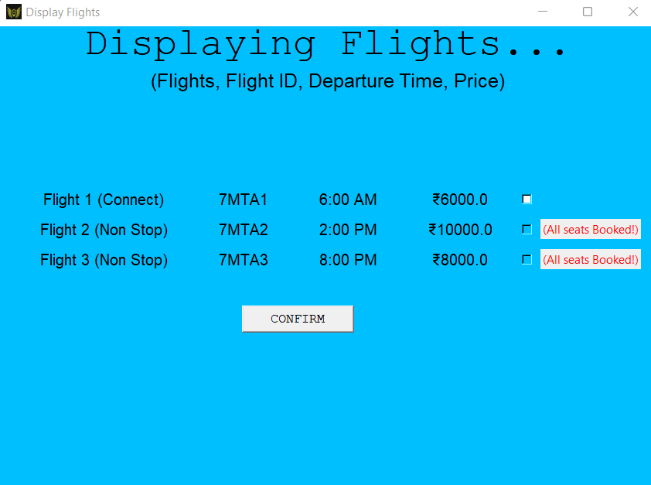

**BIBLIOGRAPHY**

1. <https://www.tutorialspoint.com/python/python_gui_programming.htm>
2. <https://www.dummies.com/article/technology/programming-web-design/python/using-tkinter-widgets-in-python-141443>
3. <https://youtube.com/playlist?list=PLCC34OHNcOtoC6GglhF3ncJ5rLwQrLGnV>
4. <https://www.imgonline.com.ua/eng/scan-qr-bar-code.php>

(To Scan QR code on Laptop)

1. <https://stackoverflow.com/questions/45067855/generating-a-list-with-string-and-number>
2. <https://stackoverflow.com/questions/10624937/convert-datetime-object-to-a-string-of-date-only-in-python>